Cookoverflow.

Content.

List of figures .

List of Tables

1.Abstract

Cookoverflow is Food Social Media Platform ,specialized in Food viewing ,recipe sharing , interacting between users and using its Data for a recipe recommender system built in the backend ,which we give the Recommender the Recipe we have, and it gives us what to cook using machine learning approach , more over we built the Platform infrastructure from Zero that matches our requirements for the Data collection and recipe Recommendation ,Users can share there recipes ,Posting them on our Platform , other users could like ,Comment on the Recipe Posts , and follow other users ,the Platform has Friendly ,Easy to use UI , reliable , and Scalable infrastructure make it very useful for Lovers of food in General , and Students who live away from there families to cook there own meals .and the Users (lovers of food ) could Communicate with each other using simple Mobile application Messenger that make it easier for them to share experiences and get the help from Professionals (chiefs ) guiding them to the best and easy ways to make there daily meals or Parties that they could invite there friends and share the best moments with the food they made ,with different Nationalities all over the world

2.introduction

2.1Problems

The Idea comes from that there isn’t a specialized Social platform for Food in general that they could interact and share experiences and meet Professionals in the industry of food ,and of course the machine learning approach make it so simple for them to find the meals they would like to cook ,with the whole instructions and recipes which make it Free and available all the time, more over Rating of recipes as more people liked them make it easier for them to find the most Popular recipe to cook ,and in the last Students that didn’t have any resources to know how they cook could find all Kinds of recipes and the instructions all in one from in our Platform , and there is no website that can offer a feature that search a recipe by its ingredients

2.2 objectives

This research aims to design a platform that Help users to search for recipes by providing the recommender system with the ingredients of the wanted recipe

This Platform comes with many features for the user, which the users can provide the recommender system the ingredient of the wanting recipe then it will return the mostly matched recipes that have the ingredient that the user provided. Moreover, the users could interact, share, follow and rate the recipes that the other users shares in the platform.

Each user has an account that he could brows all the content in the websites ,first he goes to explore page then he could follow the content he likes more ,and his account id secured and verified account by email ,and the users could reset there password in case they forget it, moreover the could edit there Data ,or posting The Recipes they made ,providing as with Data we need in the Recommender system , and manipulate these data in a recommender system to provide them with the wanting recipes in the Backend

2.3 Scope

The Product we come up with is Software +research backend Recommender system ,the website build mainly in (Django Python in the backend ,Postgres SQL as Database and it Uses MVT (Model ,View ,Template ) architecture, and the Front end built with HTML5 ,CSS3 ,JS,Bootstrab ,JQury ,and some libraries of JS , Vanilla JavaScript and Tailwind CSS , we began with design the database and Writing our APIs ,and we used Flutter for the mobile part to chatting between users,In the End we Uses the distributed version control and source code management functionality Git /Github in team work

we used Scrumban which is an Agile development methodology that is a hybrid of Scrum and Kanban ,and organizing our work and tasks to be done and completed in Trello

2.4 importance

There is no social media platform that specialize in food industry and recipe sharing ,and data collecting to benefit other users from the search Engine ,so our website provide and easy and reliable way to let users in general and students in particular to search there recipes using the Search engine(recommender system ) by ingredients , as we mentioned previously this platform aimed to help students who are far from there families, wives ,husbands and any other single person in saving time by using the search engine of ingredients and money by providing the search engine with the available ingredients of recipes ,and of course have fun and spend some time learning and trying new recipes for beginners ,and share knowledge and experience of Professional users and amateurs

3. Constraints, Standards/ Codes, and Earlier course work

3.1 Constrains

Cookoverflow is not the only social Media Platform that has Posts , comments ,or interactions ,but the Main Problem is that how we want to add futures to make it different that’s was the most difficult for us ,adding search Engine infrastructure based in its specialization was the key ,and marketing it as the only website that contain Food recipes with interactions and communication with others and were even the beginners could contribute to its contents, more over we customize the infrastructure that been built from zero with the AI search engine that been successfully deployed in the backend to the next Phase of the Research and developments Engineering

3.1.1 Dataset

Basically we faced a challenge in preparing our Data, the idea is not just Got a ready Dataset from Kaggle ,because we need it the be harmonic with what we built in the website ( Food Social Platform),so we prepared our data with what’s compatible with our vision from the Platform ,so be made web Scraping to some recipes from trusted websites ,(we choose three of them )

1.Foodnetwork.com,

2. Epicurious.com

3. Allrecipes.com

And we Scraped more than 72 000 recipes using the libraries of python 3 setuptools==28.6.1

beautifulsoup4==4.5.3 and there was three JSON files from three different websites divided to four Columns Title ,Picture URL ,Instructions ,Ingredients and After we Processed the data with Topic modeling and Text Rank and analyses the ingredients with instructions we added the tag Colum

3.1.2 hardware Problems

When we tried to use our machines (laptop’s ) to Pooling and and TF-IDF vectorized by recipe it took very long time and didn’t completed ,so we used Google Colab ,uploading all our JSON Files then we converted them to CSV , and we used Clemson University Supercomputer (Palmetto )as we had access to there Supercomputer to train our model, moreover in Web scraping from Website to make our data ready our internet connection was not enough so we go to NNU university to make that happen ,because we scraped more than 1 Tera then after Cleaning it reached the half

3.1.3 lack of similar abstractive approach in the architecture

to use and Prepare dataset from your own built website and then Deploy it again and again so we come up with micro services approach that our model talk with website database Using API ,which make the architecture design more complex so we could use DOS approach which our Model in Different server ,and the Platform in other Server and Two servers communicate with each others

3.2 standards / Codes

Most Companies and institutions have charisma and Standards that they need to follow to Adding any Feature in the Product , and in Cookoverflow we Keep Adding any possible improvement in the Process of development itself ,from Code Quality , Clean Code , Design Patterns and Time Organization

3.2.1desgin and visual identity guidelines

First of all we collect the requirements designed the UML at Draw.io , the state diagram the sequence diagram ,the User interface (Front end ), and then we assigned tasks for each one in the group ,and we write complete description to each at Trello , the we Choose a framework matches with our requirements and system infrastructure , then we used Version control (Git/Github ) to make our work as Professional as possible ,write clean code ,review each dependances , creating the python environment which is embedded in Django itself , so we live the software life cycle from requirements to design ,to implement and test and so on

3.2.2 coding conviction

when it comes to coding there are many recommend standards and best practices and sometime

these practices might vary depending on your language of choice. for example, in Cookoverflow we use

Django (Python) as our backed framework and with these came a set of guidelines that we

are recommended to adhere to you can see the full set of guidelines and best practices for Django

in this link ([Django Best Practices — Django Best Practices (django-best-practices.readthedocs.io)](https://django-best-practices.readthedocs.io/en/latest/))

3.3 Earlier course work

We tried to Use our cumulative course work and extra curriculums and Trainning we learnt during four years at the college at Computer Engineering Department :

1.DataBase :

One of the most important Courses in the university that we benefit from it to design our 27 Tables ,Draw the Diagrams (UML) ,and SQL to the Backend of our manipulation of the data we want ,we used Postgres SQL ad Database

2. Web development :

the college web development course was one of the most helpful courses

for this project since we are building a web platform for the end-users. along with a set

of extra resources especially the largest we learned Django to develop Platform Backend , and learned how to make verification to email and make our website as secure as possible

• Software engineering: all the development operations (DevOps) that were implemented during

the project was out of the things we learned during the Software engineering course and the

code standards and app workflow design.

• Artificial intelligence: the artificial intelligence course was the core for all the progress we

made in our research since without it we won’t be able to understand any concept while

taking further advanced courses to achieve our goal of building an AI search Engine For Recipe ingredients

• Software engineering

Dig deeper in the development and architecture of the website and the pipelines Building the Signal API architecture for the notifications in the Platform and adding likes and so on

• Security even though we didn’t take the security course but we took the basics during the

network course and we extended our knowledge throw online tutorials to implement Django authentication

• Mobile :

We built simple flutter app to chatting between users of the website

•machine learning

We took course with Clemson University helped us to implement the unsupervised learning clustering technic and Built the Recipe Search Engine AI

4. literature review

In this Project we tried to add a special feature that all website aiming to have from its users which is collecting data from website and Processing them in a Machine learning Model then deliver them to users as a recommendations so in this section we will discuss the AI/ML Life cycle from Data Collection ,cleaning ,parsing ,modeling ,and make the end to end connecting points with the Backend then the deployment of the model making every step corresponding with the requirements of the Product we tried to achieve :

**The Data :**

We scraped the Data from three websites ,72 000 recipes ,as JSON then during the Preprocessing and cleaning we convert them to .CSV

The Scraping Done by these Two liberties setuptools==28.6.1

beautifulsoup4==4.5.3

in this format as Shown in the Code :

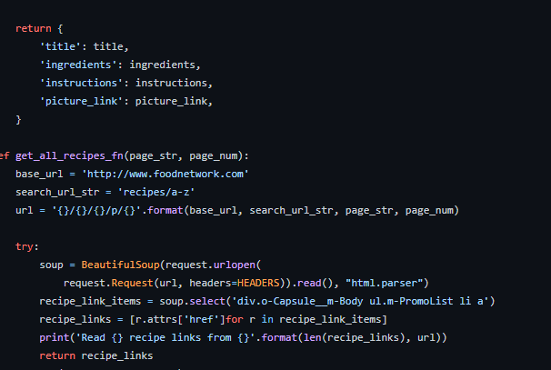

Here are the Result of The Scraped Recipes:

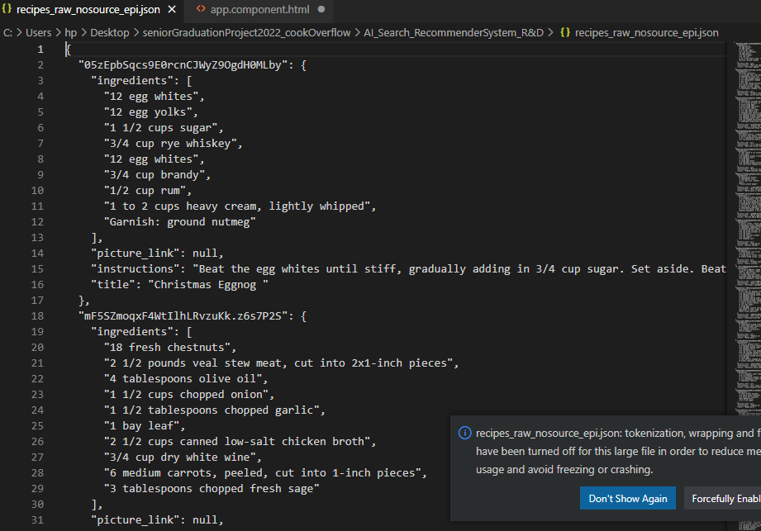

**PROPOSED WORK (ALGORITHM/MODEL/APPROACH)**

***3.1 Algorithm & Approach 1.***

Scrap Dataset from given websites:

1. All Recipes

2. Epicurious

3. Food Network

4. our Own website

.

**2. Preprocessing Dataset:**

1. Filtering out incomplete recipes and converting the dictionary to string.

2. Add stop words after recipe title, ingredients and instructions.

3. Fixing the length of recipes by removing too large recipes and padding the smaller ones with a special character.

Finally left with 72000 recipes.

3. NLP : We have used used character level RNN’s where we have first vectorized the input dataset into numbers and then converted them into a Tensorflow dataset for final training.

4. Then we split up the dataset into batches of 64 and final started the training.

5. We have applied different Deep learning: 1. Optimizers: Adam, RMSProp & SGD(Stochastic Gradient Descent). 2. Learning rate: varying from 0.005 to 0.001 3. Loss Function: sparse_categorical_crossentropy & categorical_crossentropy We were able to successfully achieve a best accuracy of 93.20% using RMSProp Optimizer, sparse_categorical_crossentropy as the loss function and 0.0005 as the Learning Rate. (But the Was under Research ) we didn’t Apply it to the Final Version of the Product )

3.2 Model

The system we have built will be used for Recommendation of Recipes based on ingredients from the given set of input and thus also requires proper designing. The Design requirements for the project are: 13

3.2.1 Knowledge Requirement for Modeling

a) Knowledge of Web Development: To develop the registration process and the recipe recommendation and Search AI algorithm process, the knowledge of Web Development was required. The team has knowledge of Web Development, and has used Cookoverflow uses JavaScript, CSS, AJAX for the front-end and Django , a Python framework, for the server-side scripting needs & finally PosgresSQL as the database

. b) Knowledge of Machine Leaning Especially Unsupervised Learning : Since the application required designing a model which could help Clustering the Recipe based on NLP Tags , the knowledge of Unsupervised Learning was required. Our team had knowledge of Neural networks, and our application specifically used RNN’s(Recurrent Neural Network).

c) Knowledge of UML Diagrams: Knowledge of UML diagrams was essential to create the different types of models which is an essential component of Software Engineering and Design architecture.

3.3 Modelling the Architecture

a) Server: The system requires servers to process applications and to host databases, to and from which the querying is done. For development purposes the team has used their local machines and For Microservices Architecture the ML Model Was in Supercomputer

. b) Web Hosting: The application and databases are required to be hosted on the web, to provide anytime access to them. For development, the team has used the localhost to host applications.

c) IDEs: Since various technologies are being used, specialized IDEs and tools are used for them. The team has used:

I Pycharm and VSC and Web Development.

II. Jupyter Notebook for Development of Python Script.

d) tools :

1.Git/GitHub Version Control ( DesvOPs)

2.Google Colab ,Palmetto (Super Computer of Clemson )

3. Draw.io For UML Drawing

4.Overleaf (Design The Paper on Cambridge Template ) ,LaTeX

5. PowerPoint (Presentation)

6. Trello (Agile Development Process )For Team work ,Assignment of Tasks

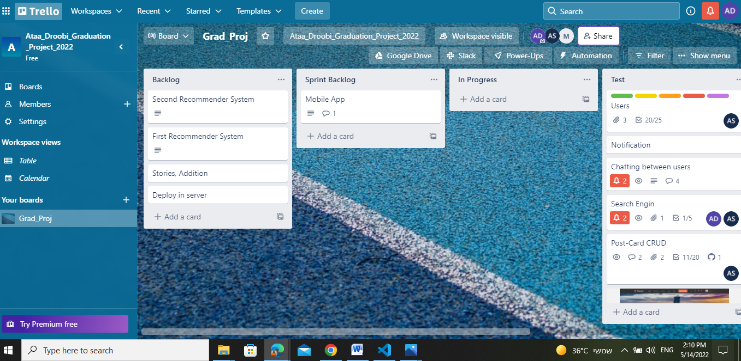

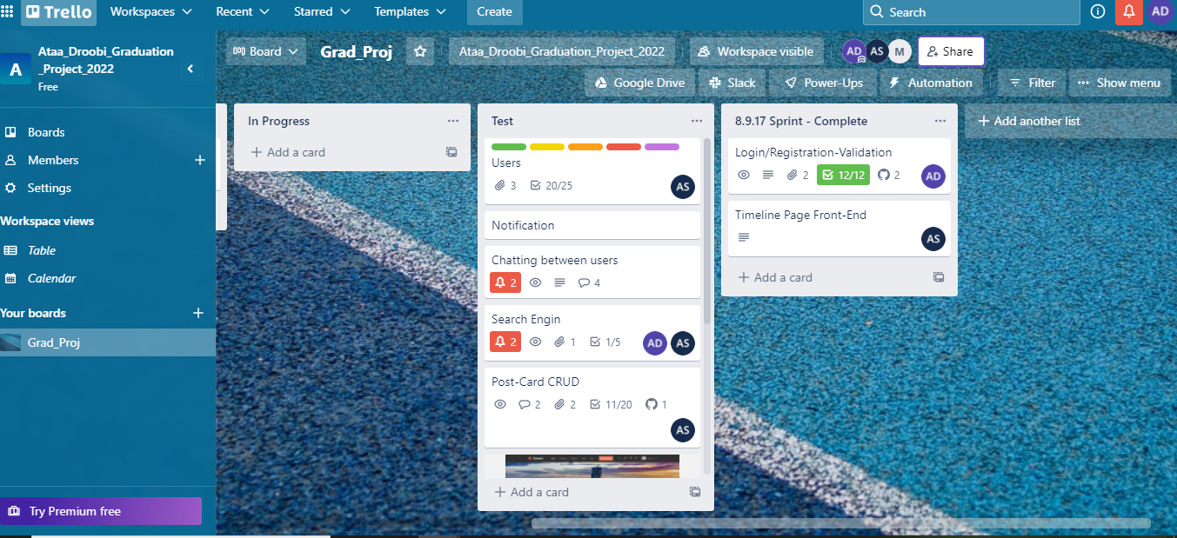

5.methodology

6.results and analysis

7. conclusion/ recommendations and future works

7.1 conclusion

7.2 future works

Much can be done as future work regarding our our approach in Search engine for recipes and its

use in a Social Media Platform. With the concept of Recipe matching being a fundamental

component in daily cooking routine, we aim to develop a more accurate and human-similar recipe detection model. Furthermore, regarding the stages Recipe Search engine, future work includes a more thorough investigation into visual features to increase the system’s performance and computation time using DOS and microservices architecture. More importantly, a contribution can

be done by collecting a new and higher quality Recipe dataset, and providing its

corresponding user-based and golden-standard annotations and of course adding it more accurately from our Platform . Finally, we plan on enhancing the application by enlarging and improving its Recipe storage repository, and improving Ai search and making it a more user-customized environment. And Adding Arabic Languages to the recipes after collecting and creating Data from the Platform it self after its release

9. appendices and references

[1]. Discovery of Recipes Based on Ingredients using Machine Learning S. Praveen, M.V. Prithivi Raj, R. Poovarasan, V. Thiruvenkadam, M. Kavinkumar (International Research Journal of Engineering and Technology (IRJET))

[2]. Forage: Optimizing Food Use With Machine Learning Generated Recipes Angelica Willis, Elbert Lin, Brian Zhang

10. website components